The brittle star (also called the serpent star) is a spiny, hard-skinned, long-armed animal that lives on the rocky sea floor, from shallow waters to great depths. **They along with seastars belong to the clade Stelleroidea:** This cade may be further divided into two clades by some taxonomists, true star fish **(**Asteroidea), and brittle stars and basket stars (Ophiuroidea).

Most brittle stars have five (or a multiple of five) long, thin, spiny arms that radiate from a flat central disk; the arms do not touch each other at their bases. Many of the arms are forked. If a brittle star's arm is cut off, it will **regenerate** (regrow). We now know that in some species the dorsal surface is covered with enormous numbers of tiny, calcareous crystalline lenses essentially forming a ‘huge’ eye that is extremely sensitive to light. There are other differences between this group and true star fish. The madreporite in starfish is on the aboral (dorsal) surface whereas in ophiuroids it is located on the oral (ventral) surface–when visible; it is often difficult to detect at all. The oral surface of a starfish has a “channel” running down its length and that is where the tube feet are located, whereas in the ophiuroids, there is a series of plates running down the length of the arms and no channel. The tube feet are modified and serve primarily as tactile organs.. The connection of the arms to the central disk in starfish is such that they are usually seen as an extension of the disk, whereas in the ophiuroids, the arms are quite distinctly demarcated and it is this jointed character that allows for the fluidity of their movement. Brittle stars use their whip-like arms to make their way from place to place, commonly using them to cling to sponges, corals, or even other animals. Brittle stars also have a specialized endoskeleton with **vertebral ossicles**, which resemble true vertebrae with ball socket joints, to support their arms during speedy movement. Simple muscles allow the arms to move.

Watch the video below (from1.2o to 2.20 minutes) to see a swimming brittle star.

<https://www.youtube.com/watch?v=ejk-R-LPFys&t=141s> before starting your observations.

**Observations.**

Watch your animal move. Note how light sensitive it is and how quickly it can move on detecting the change in light.

External anatomy

Look at the aboral (dorsal) surface of the disk and arms with magnification**.   Ophiuroids have no papulae, no pedicellariae, and no paxillae such as are common in asteroids.   Th**e epidermis is a thin, non-ciliated syncytium and most of the body wall is a connective tissue dermis, which contains abundant calcareous ossicles of many sizes and shapes and are often known as shields. For example, there are often two large oval radial shields at the base of each arm.

 Turn the animal over and examine the oral surface of the disk with magnification. Unlike that of the aboral disc, the epidermis of the oral disk is ciliated. Try to identify the structures below.

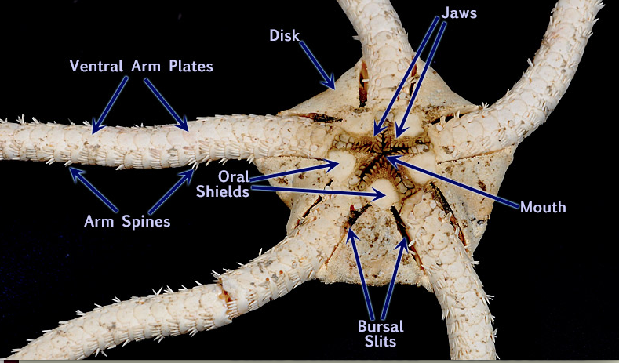

 An important echinoderm characteristic is the water vascular system that in most groups functions in support of locomotory tube feet but is also important in gas exchange, excretion, and feeding.  See if you can locate the madreporite or the opening to the water vascular system. It should make one of the oral shields, “odd” shaped. You may have to focus at high power to see it. In some species, it can be covered by ossicles and may be impossible to see under the stereo scope without injuring the specimen.

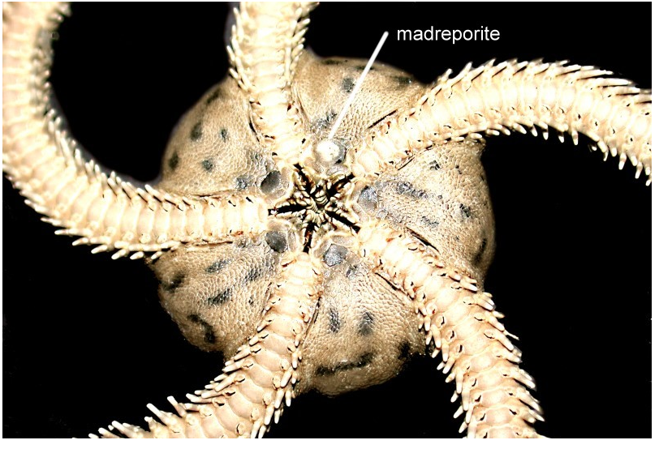

Try to locate the modified tube feet on each arm A pair of small **tentacular spines** protects the base of each **tube foot**, or podium.   Ophiuroid tube feet are sometimes called tentacles.  They do not have suckers and their ampullae are tiny.   They may resemble arm spines.   Touch a suspected tube foot with a microneedle.   If it is soft and flexible it is a podium.  If hard, then it is a spine.  In some genera, the base of each tube foot is protected by a hinged, movable tentacle scale.  Look for it and lift it with a microneedle to reveal the base of the foot.

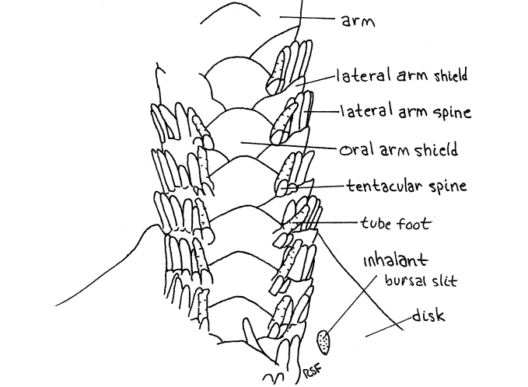

**You should be able after viewing the brittle star, have viewed the unique characteristics regarding anatomy associated with movement and the water vascular system. You should have obtained photographs showing tube feet, the oral disk and madreporite.**